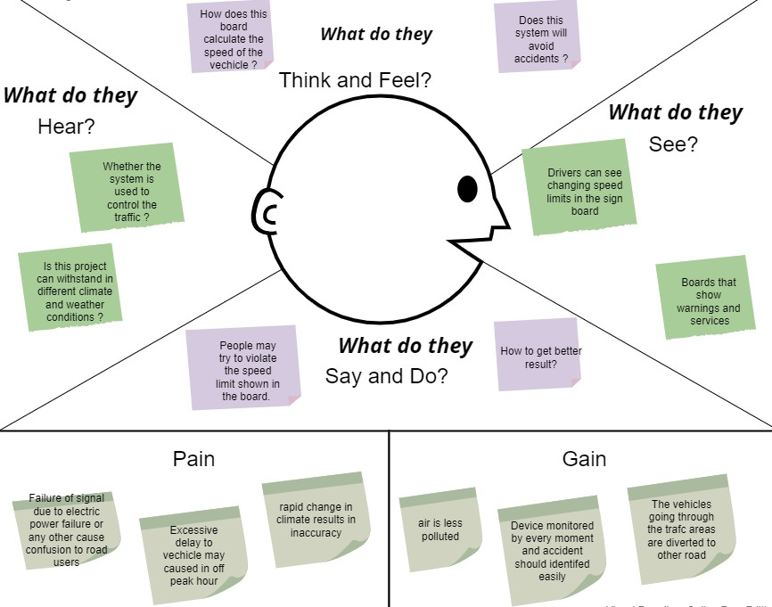

Signs with Smart

Connectivity for

Better Road Safety